Eastern China Tour:
Duration: 6 Days / 5 Nights tour (December 23, 2006)
Itinerary: Hong Kong – Shanghai – Zhuozhuang – Suzhou – Hangzhou – Hong Kong
Day 1: Hong Kong – Shanghai (Dinner included)  Meet and greet at the Hong Kong International Airport in the afternoon and fly to Shanghai. Then join our short city tour to learn about the history of this amazing city. After the dinner, a night cap at Xintiandi, the trendiest hangout with pubs and bars in Shanghai, a finest representation of Shanghai as a cosmopolitan city in modern china. The outlets in Xintiandi convert the city’s unique “Shikumen” houses (literally meaning ‘stone gate’, a special form of architecture for residential purposes) and a maze of narrow alleys. |  | 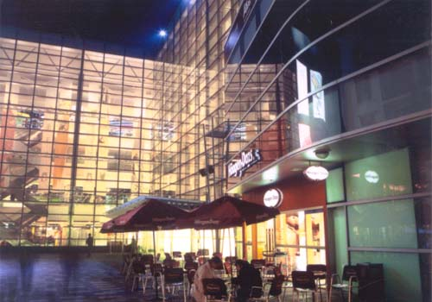
Day 2: Shanghai (Breakfast, Lunch & Dinner included)  After the Breakfast, we will take you to discover the classical Yu Yuan Garden and the Quaint Old Town Bazaar. The Garden is the best example of classical gardens of Shanghai. Built in 1559, the garden is laid out in an intricate manner. As a paragon of the south Chinese landscaping style of the Ming and Qing dynasties, it is a must for all visitors to Shanghai. The neighboring Yuyuan Bazaar, also known as “Old City God’s Temple Market”, is an assemblage of shops, restaurants and recreational facilities. Then, stroll along the Bund Waterfront and visit the vast Shanghai Oriental Broadcast Tower. In the evening, enjoy a famous acrobatics show after dinner. |  | 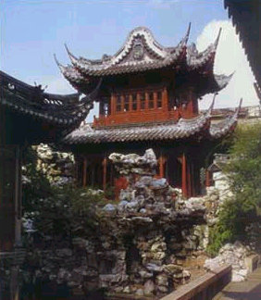
Day 3: Shanghai – Zhuozhuang – Suzhou (Breakfast, Lunch & Dinner included)  In the morning, set off for the timeless water village of Zhuozhuang. You can expect breathtaking surroundings and simple, old buildings and tucked away in a labyrinth of mirrored rivers and lakes. Zhuozhuang collects all beauty of water-towns as Huangshan contains all beauty of mountains. Take the coach to Suzhou and check into the hotel for the night. |  | 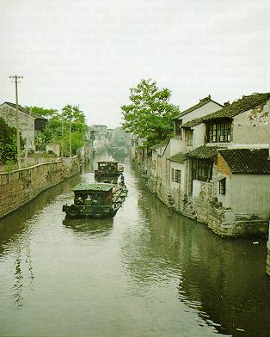
Day 4: Suzhou – Hangzhou (Breakfast, Lunch & Dinner included)
After the breakfast in the hotel, coach to Tiger Hill, the Garden of Master of Nets and the absorbing Institute of Embroidery. There is a pagoda on top of the Tiger Hill, which has slanted until its top deviated 2.34 meters from its axial line – the Leaning Tower of Pisa in the East. The park is also the venue of the annual flower show and temple fair. Suzhou embroidery is best known in China, famous for its impeccable and sophisticated needlework, graceful patterns and a serene artistic style. Take the coach to Hangzhou in the afternoon.
Day 5: Hangzhou (Breakfast & Lunch included)  Today, we will bring you to a boat trip to the ravishingly beautiful West Lake. The lake is 5.6 square kilometers in size and it is surrounded by hills on three sides. It is an earthly paradise especially the Eight Beautiful Sports of West Lake. Then, visit the graceful Pagaoda of Six harmonies which its brick and timber structure is a precious heritage of China. You will also visit the Historic Lingyin Monastery. |  | 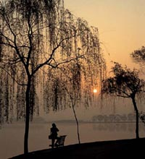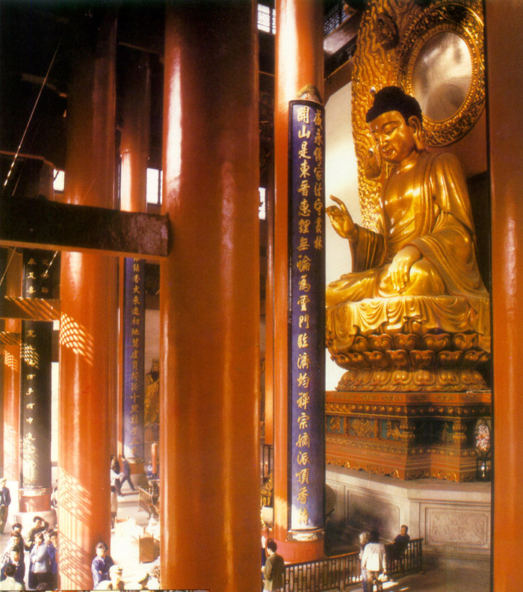
Day 6: Hangzhou – Hong Kong (Breakfast)
Free Leisure time for you in the morning. Flight will depart in the afternoon and shuttle will be arranged for you to the airport from the hotel.
USD1,100.00 per person (Share Twin) | Single Room Supplement Cost: USD280.00
** Guarantee for departure with min. of 2 pax.
** Please see Tour Regulations for tour details.
Tour Regulations:

All the above tours are inclusive of:
- English speaking tour guide
- transfer by shuttle bus as mentioned in the itineraries
- Economy class airfare, if applicable
- Hotel accommodation (Half twin basis), Single Room Supplement charge will apply to Single traveler.
- Breakfast, lunch or dinner which as specified in the itinerary
- All admission fee to attractions as specified in the itinerary

All the above tours are exclusive of:
- China Visa Fee
- China, Taiwan and Hong Kong Airport taxes (To be confirmed upon the tour is guaranteed for departure)
- Hotel accommodation costs and the incidental expenses at hotel
- Excess luggage charges
- Tips for the driver and the tour guide

Remarks:
- All the above itineraries are subject to change due to unforeseeable situation out of CTS’s control, CTS will adjust the itinerary based on the actual situation.
- It is clients’ responsibility to bring the valid passport, identification cards and China Visa.
- The single room supplement will be added to the basic tour price for individual traveler(s).
- The information listed above for entry and exit China transportation and date is for reference only and is subject to change without prior notice.
- Since there is a possibility that the applicant may not be able to get the China VISA, we strongly suggest all participants should have their visa ready at least 1 week before the departure of the trip. If guest choose to do the group VISA and his/her application does not go through, there will be no refund of the trip.
- Hotels reserved for the above tours are 4 stars or similar hotels.
- We strongly suggest client purchase their tour insurance for their assurance.
- Cancellation Policy:
  - All cancellation must be made by the tour participants in writing or in person:
    - 14 working days and before prior to departure: 15% of the total tour fee.
    - 6-13 working days prior to departure: 60% of the total tour fee.
    - 6 working days or less prior to departure: no refund.

