Shenzhen – Guangzhou Tour
Duration: 3 Days / 2 Nights Departure on Dec 23, 2006 Saturday
Itinerary: Hong Kong – Shenzhen – Guangzhou – Foshan – Ping Zhou – Hong Kong
Day 1: Hong Kong – Shenzhen (Lunch and Dinner inclusive)  Meet and greet at the Train station and take the first-class train to Shenzhen. Explore the city with the comfy coach. Follow with a visit to the Terracotta Warriors and Horses exhibition. Spend the afternoon at the two of the most spectacular theme parks in Shenzhen – China Folk Culture Villages and Splendid China. Transfer to designated hotel after dinner. | 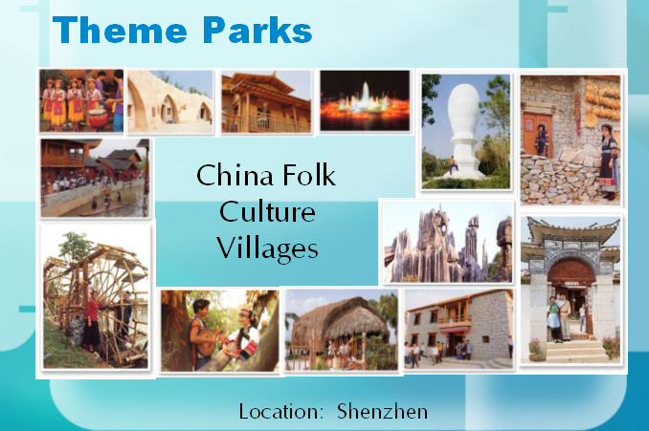
Day 2: Shenzhen – Guangzhou (Breakfast, Lunch and Dinner included)  Meet and greet at the hotel lobby and transfer to the train station for the morning train to Guangzhou. Take our coach to Dr. Sun Yat-sen Memorial Hall and Chen Family Ancestors. Dr. Sun Yat-sen, the Father of Republic of China. The Chen Family Temple, also known as Guangdong Folk Art Museum, was built in the 1890s and has nine halls and six courtyards. Its windows, door frames, and pavilions are lavishly decorated with intricate carvings and sculptures. It is now the largest and best preserved and decorated ancient architecture existing in Guangdong province. Take the coach and transfer to rural Panyu and spend a short time walking around the Lotus Mountain. Have dinner at the local restaurant and transfer to designated hotel. | 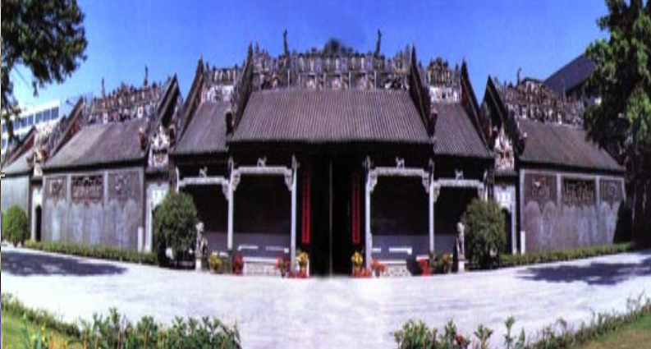
Day 3: Guangzhou – Foshan – Ping Zhou – Hong Kong ( Breakfast and Lunch included)  Transfer to Foshan in the morning and visit the Foshan Ancestral Temple with eight centuries of history. Then, a visit to the ceramics workshop and a folk art studio for delicate handicrafts, where Foshan’s most spectacular handiwork can be found. Follow with a visit to Liang’s Garden where you can find the most magnificent Stone Scriptures. Transfer to Pin Zhou Pier and take the catamaran back to Hong Kong. | 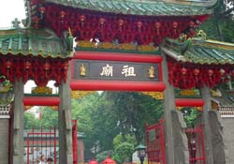
USD380 per person (Share Twin) | Single Room Supplement Cost: USD150.00
** Guarantee for departure with min. of 2 pax.
** Please see Tour Regulations for tour details.
Tour Regulations:

All the above tours are inclusive of:
- English speaking tour guide
- transfer by shuttle bus as mentioned in the itineraries
- Economy class airfare, if applicable
- Hotel accommodation (Half twin basis), Single Room Supplement charge will apply to Single traveler.
- Breakfast, lunch or dinner which as specified in the itinerary
- All admission fee to attractions as specified in the itinerary

All the above tours are exclusive of:
- China Visa Fee
- China, Taiwan and Hong Kong Airport taxes (To be confirmed upon the tour is guaranteed for departure)
- Hotel accommodation costs and the incidental expenses at hotel
- Excess luggage charges
- Tips for the driver and the tour guide

Remarks:
- All the above itineraries are subject to change due to unforeseeable situation out of CTS’s control, CTS will adjust the itinerary based on the actual situation.
- It is clients’ responsibility to bring the valid passport, identification cards and China Visa.
- The single room supplement will be added to the basic tour price for individual traveler(s).
- The information listed above for entry and exit China transportation and date is for reference only and is subject to change without prior notice.
- Since there is a possibility that the applicant may not be able to get the China VISA, we strongly suggest all participants should have their visa ready at least 1 week before the departure of the trip. If guest choose to do the group VISA and his/her application does not go through, there will be no refund of the trip.
- Hotels reserved for the above tours are 4 stars or similar hotels.
- We strongly suggest client purchase their tour insurance for their assurance.
- Cancellation Policy:
  - All cancellation must be made by the tour participants in writing or in person:
    - 14 working days and before prior to departure: 15% of the total tour fee.
    - 6-13 working days prior to departure: 60% of the total tour fee.
    - 6 working days or less prior to departure: no refund.

