Modeling Agent-Based Load Balancing with Time Delays

1 Backgrounds

Grid computing is originally motivated from large-scale scientific computation where supercomputers are often needed. Scientists try to integrated idle computers on networks to a “computing grid” to replace the supercomputers. After a large-scale scientific computation is decomposed into different independent tasks, the remained problem is to disperse the tasks, that is, to balance the tasks on different idle computers on networks.

Traditionally there is a master who disperses tasks to his slaves. This is not applicable in grid computing as the networks of idle computers lack fixed structures. In a natural environment, a group of ants can collect objects into piles without any master. This phenomenon gives a clue to solve our problem.
Resnick simulated the phenomenon by artificial ants and found that in order to collect objects into piles, the ants only need to obey three simple rules: (i) Ants wander around randomly until it encounters an object; (ii) If it was carrying an object, it drops the object and continues to wander randomly; (iii) If it was not carrying an object, it picks the object up and continues to wander.
The goal of Resnick's artificial ants is to collect objects. In order to disperse tasks on networks, Montresor and Meling made simulations
by their artificial ants whose rules are inverse to those in Resnick's simulations, that is, ants which carry objects leave their objects behind only after they have wandered about randomly for a while without encountering object concentrations.

In one of their experiments, there are 100 idle nodes on grids. Initially there are 10,000 tasks on a node. Twenty ants are generated to disperse the tasks. The ants obey the above three rules. After 50 iterations, the tasks are evenly dispersed on the idle nodes, that is, there are 100 tasks on each idle node.

2 Load Balancing Mechanism
The agent-based load balancing we concern is as follows. Initially a pile of tasks is generated on networks. Then a pile of agents, whose
number is equal to that of the tasks, is generated. Each task is carried by an agent. We regard a task as an agent. The agents wander on networks and search proper nodes to join and queue. The time delay is that a single agent spends on wandering in order to meet a node.

3 Macroscopic Characterization without Time Delays

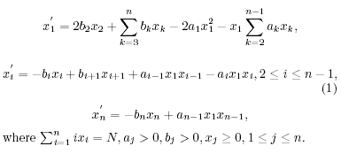

4 Macroscopic Characterization with Time Delays

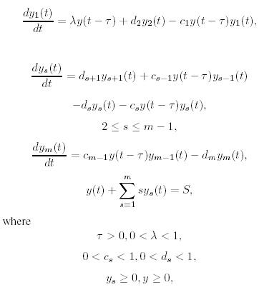

5 Dynamics of Load Balancing with Time Delays

We show that although there is a period of oscillation, the dynamic behavior tends to a steady state, which is in agreement with the recent experiments through Anthill. An interesting phenomenon is shown: the larger the delay, the longer the period of oscillation; the larger the delay, the slower the convergent speed of load balancing.

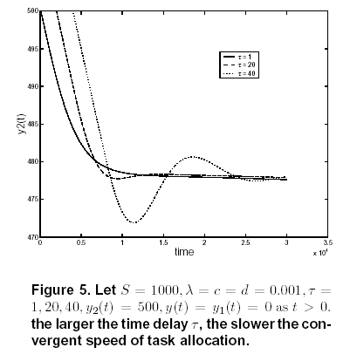

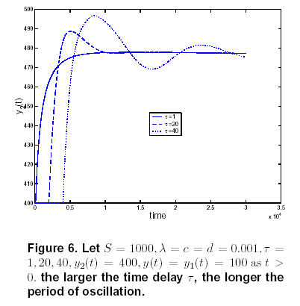

6 Further Study

- How does the efficiency (utility gains) of load balancing vary during different time periods?
- How do steady states vary with single agents' strategies of leaving and queuing?
- How do steady states vary with different initial conditions?

