What Is Constraint Computation?
Making Hard Choices Easier

Cork Constraint Computation Centre

Difficult problems can offer too many choices, many of which are incompatible, few of which are optimal. The Cork Constraint Computation Centre (4C) develops the basic science that will make it easier for computers to help us make these choices.

Some examples of constraints:
- The meeting must start at 6:30.
- The separation between the soldermasks and nets should be at least 0.15mm.
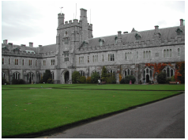
- This model only comes in blue and green.
- This cable will not handle that much traffic.
- These sequences should align optimally.
- John prefers not to work on weekends.
- The demand will probably be for more than 5 thousand units in August.

Some examples of constraint satisfaction or optimization problems:
- Schedule these employees to cover all the shifts.
- Optimize the productivity of this manufacturing process.
- Configure this product to meet my needs.
- Find any violations of these design criteria.
- Optimize the use of this satellite camera.
- Align these amino acid sequences.

Constraints arise in design and configuration, planning and scheduling, diagnosis and testing, and in many other contexts. Constraint Programming can solve problems in telecommunications, internet commerce, electronics, bioinformatics, transportation, network management, supply chain management, and many other fields. Constraint computation has seen fundamental scientific advances, e.g. in understanding the relationship between problem structure and problem complexity. Constraint technology has demonstrated its commercial value.

Research Agenda
We apply advances in artificial intelligence and other disciplines to make constraint programming more powerful, more practical and easier to use. The work is centred in the field of artificial intelligence, but embedded in the broader constraint programming community. The center conducts basic research in areas vital to the next generation of constraint technology.
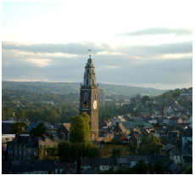

Specifically, the Centre seeks advances in:

Automation
The process of modeling domain knowledge, tailoring heuristics, and
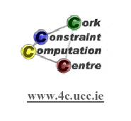
exploring alternatives must become more automated. Specific topics include acquisition, validation, optimisation, learning, and explanation. Progress can be made here by abstracting our experience with specific applications.

Applications
Applications will motivate and validate advances in automation. Application domains may include bioinformatics, configuration, computer and telecommunications networks, design, electronic commerce, planning and scheduling.

Adaptability
In the real world we are confronted with uncertainty and change, with probabilities and preferences, with failures and tradeoffs, with collaborators and competitors. New applications and new contexts, e.g. interactive internet applications, present new challenges. Constraint technology must be further enriched to cope better with these challenges.

History
The Cork Constraint Computation Centre (4C) was established in October of 2001 when Professor Eugene C. Freuder received a Science Foundation Ireland Principal Investigator Award and moved his research lab from the University of New Hampshire in the U.S. to merge with the Constraint Processing Group in the University College Cork (UCC) Department of Computer Science, headed by Professor James Bowen. Professor Freuder became the Director of 4C and Professor Bowen the Co-Scientific Director.
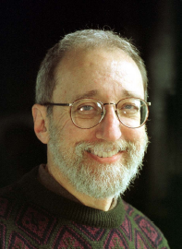
Professor Eugene Freuder
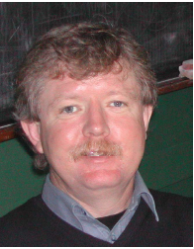
Professor Jim Bowen

In 2002 Dr. Toby Walsh received a grant from Science Foundation Ireland and became the Deputy Director of 4C. 4C is attracting additional funding from government and industry, and will soon have three dozen academic, research, administrative and student staff members.
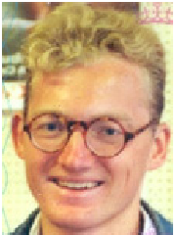
Professor Toby Walsh

Human Capital
4C started with five students in the fall of 2001 and expects to have seventeen in the fall of 2002. Eight of these will be supported by Enterprise Ireland grants and one by the Irish Embark Initiative. Undergraduates also began gaining experience at 4C starting in the summer of 2002. 4C staff were involved in organizing programs for young scientists in the European artificial intelligence community and the international constraint programming community. Gene Freuder was invited to speak to both groups of young scientists. Chris Beck and Toby Walsh each gave tutorials at the American Association for Artificial Intelligence Conference in Edmonton, Canada in 2002.

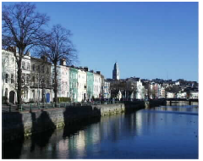

Technology Transfer
4C receives support from Xerox Corporation and cadcoevolution. 4C has already visited or been visited by Bouygues, ILOG, LPA, RaidTec, Synopsis and Kinematik. Jim Bowen and Barry O’Sullivan were two of the founders of Suntas Technologies. Gene Freuder is on the Technical Advisory Boards of ILOG and Celcorp and Senior Technical Advisor of Ecora. Dr. Jim Little, who has extensive industry experience, is the 4C External Liason Officer. Members of 4C have worked with many companies in the past including Oracle, Concentra, Nokia, Trilogy, ILOG, Lucent, Calico, Candle, Cabletron/Aprisma, Xerox, Ecora, British Telecommunications, Digital Equipment Corporation, Imperial Chemical Industries, IBM, Westinghouse, Zuken-Redac, Celestica, International Computers Ltd., Frequentis, Baan, and Grundfos.

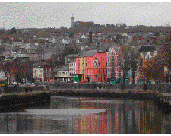

International Outreach
4C is bringing international meetings to Ireland. In 2002 4C hosted a joint workshop of the European Research Consortium for Informatics and Mathematics Working Group on Constraints and the European Network of Excellence in Computational Logic area on Constraint and Logic Programming. Barry O’Sullivan, Toby Walsh, and Gene Freuder were among the Organizers. In 2003 the International Conference on Principles and Practice of Constraint Programming will come to Ireland, with Jim Bowen as Conference Chair, in 2004 the International Joint Conference on Automated Reasoning with Toby Walsh as Conference Chair. In its first year: 4C members presented papers and helped organize workshops at scientific meetings in France, Cyprus, Canada, Italy, and the United States. Gene Freuder and Toby Walsh were Invited Speakers at scientific meetings in France, Cyprus, Austria, and Italy. 4C hosted visitors from England, France, Germany, Italy, Morocco, Sweden, Turkey, and the United States. Research collaborations were pursued with scientists in the U.S., U.K., Sweden, Germany, France, Spain, and Italy.

Contact Information

Director:
Professor Gene Freuder
E-mail: e.freuder@4c.ucc.ie

External Liaison Officer:
Dr. James Little
Phone: +353-(0)21-4255410
E-mail: j.little@4c.ucc.ie
Post: 4C, UCC, Cork, Ireland

Website: www.4c.ucc.ie

