
Xi'an, also called Chang'an, once the largest city in the world, is perhaps one of the most fabulous cities in China. For more than 1,100 years until the 10th century AD, this city in central China was the capital of 13 dynasties, including the great Han dynasty and the Tang. The Terra-cotta Warriors and Horse of Xi'an, is the greatest archeological found of this century. The other landmark like Big Wild Goose Pagoda mirrors China's long history.

The sightseeing is offered as list
Tour code | Sightseeing | Cost  (USD, p.p.) | Departure
A(East line) | Terra-Cotta Warriors and Horses Museum, Emperor Qinshihuang’s Mausoleum, Huaqing Pool, The Terracotta Soldiers and Horses Reproduction Factory | 33
B(City tour) | Shaanxi Provincial Historical Museum, Big Wild Goose Pagoda, Tang Dynasty Paradise | 26
C(East line) | Mount Huashan | 46
D(West line ) | Famen Temple, Qian Mausoleum, Princess Yongtai’s Tomb, The General Factory of Xi’an Special Technical Art | 33
Package include: lunch, guide, entrance fee and transportation in coach .

★ Terra-Cotta Warriors and Horses Museum The most significant archeological excavations of the 20th century. Over 8,000 clay soldiers and horses will take you back into the ancient Warring States period .

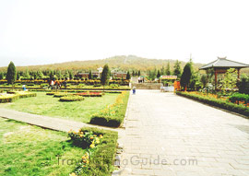
★ Emperor Qinshihuang’s Mausoleum
1.5 kilometres to the west of Terra-Cotta
Warriors and Horses Museum, for the first
emperor of China.

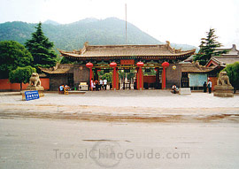
★ Huaqing Pool Being a villa palace and resort for emperors and kings in anceint times， it has a history of more than 3000 years. The Tang Emperor Xuanzong and his concubine Lady Yang often came here for pleasure.

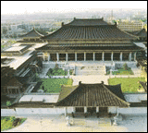
- Shaanxi Provincial Historical Museum
Houses more than 110，000 pieces
of historical and cultural relics，of which
the 3，000 objects on display. It is an ideal
place for learning about the origins and
development of ancient Chinese history.

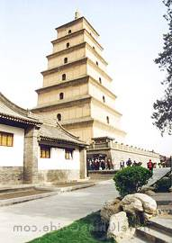
★ Big Wild Goose Pagoda Built in 652 AD , 64 meters high，with seven stories, where widely renowned Master Xuanzang (Monk Tripitaka) stored his classics brought from India.

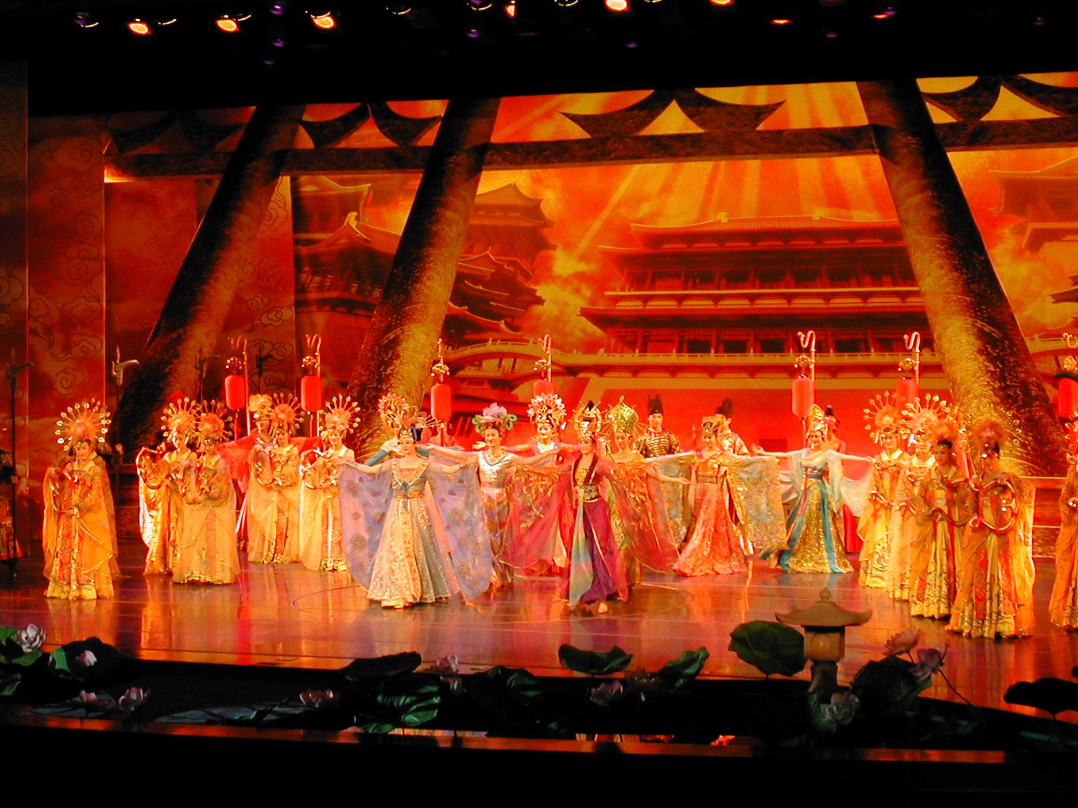
- Tang Dynasty Paradise A theme park
featuring the culture of the Tang Dynasty (618-
907AD). Over 15 million dollars were invest here.
In addition, you will see a brilliant performance
of Tang music and dance over a thousand years
ago. It has been recreated in accordance with
various historical records as well as ancient art
and relics discovered in Xian. This show has been
treasured as a national art that reflects the glory
and richness of the Tang Dynasty era.
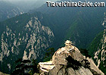
★ Mount Huashan One of five distinguished mountains in China, 100 kilometers from Xi'an, famous nationwide for its steep face.The summit is 2,160 meters above level. Cable car is offered.

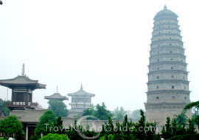
- Famen Temple 100km to the west of Xi’an,
in which the pagoda stands used to be an imperial
temple from dynasty to dynasty. In 1987, an under-
ground palace of Tang Dynasty was discovered
beneath the foundation of the pagoda and many
royal treasures and jewellery were found. The most
precious are the four slivers of veritable finger bone
of the Sakymuni Buddha.

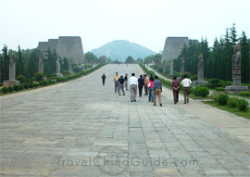
★ Qianling Mausoleum This great mausoleum occupies a prominent site on the summit of Liangshan Hill, constructed for the unique female king of China, Empress Wuzetian and her husband.

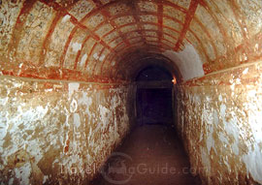
- Princess Yongtai’s Tomb
Yongtai was the granddaughter of
Empress Wu Zetian. This was the first
tomb to be excavated and remains the
most impressive of all the satellite tombs
in Qianling.

