

<Project Name/Project ID>

High-Level Technical Design
Version X.X
DD/MM/YYYY

Document Tracking
The following chart is used to log of all changes made to this document.
Version | Date of edit/change | Who made the edit/change | Description of edit/change
0.1 | Mar 13, 2021 | David King (Sr. analyst) | Initial version
1.0 | Mar 14, 2021 | David King (Sr. analyst) | Final version

Introduction
Provide identifying information for the existing and/or proposed automated system or situation for which the High Level Technical Design applies (e.g., the full names and acronyms for the development project, the existing system or situation, and the proposed system or situation, as applicable). Summarize the purpose of the document, the scope of activities that resulted in its development, its relationship to other relevant documents, the intended audience for the document, and expected evolution of the document. Emphasize that the High Level Technical Design is completed during the Concept Phase of the Investment Lifecycle and is intended to describe the conceptual design of the proposed system. This document provides a framework for more detailed requirements and design activities in later phases of the project.

Project Overview

Provide high-level information of the project. What is being proposed and the business reasons for recommending the solution.

Objective
Describe the Objective of the project.

Business Case
Provide the business case for the project, including the problem being solved, who/what area is impacted, and the business benefits of the project. (A few sentences will be sufficient)

Risks
Document specific risks that have been identified or that should be considered.

Out of Scope
Delineate specific activities, capabilities, and items that are out of scope for the project.

Technical Design Diagram
Provide a diagram that illustrates all new and existing technical resources required for the successful completion of this project. The diagram should include the following:
How new infrastructure will be located and how it will connect within existing enterprise infrastructure.
Servers, storage, network – assume all are virtual unless there are specific technical issues that are expected to require physical resources.
Logical data flow.
Critical ancillary equipment or connections where needed.

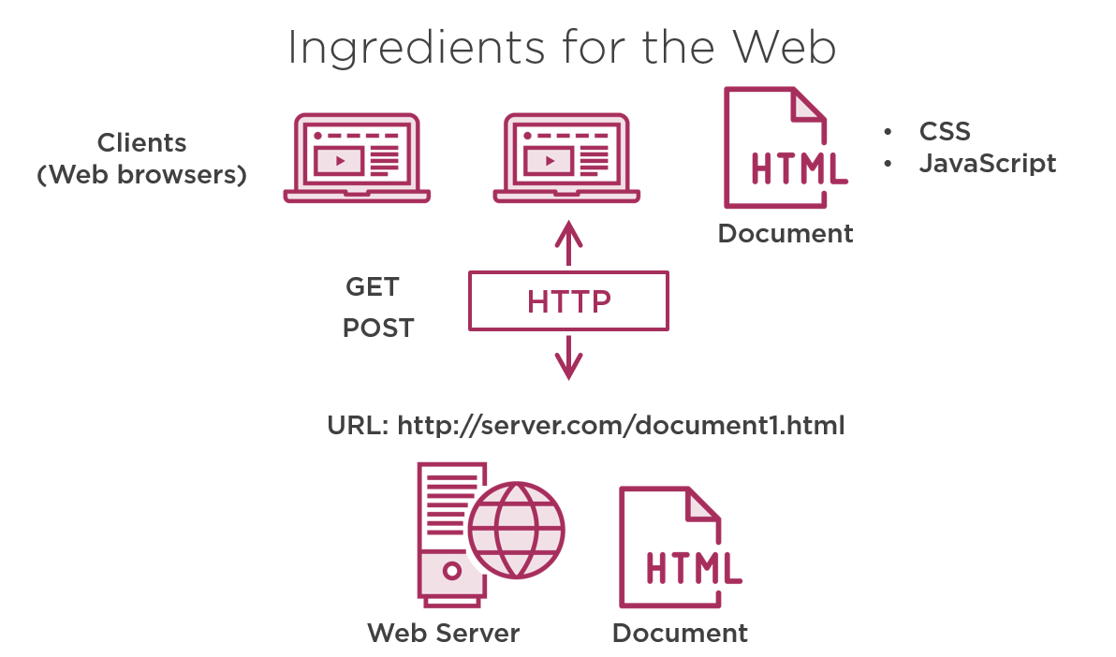

Technical Specifications
Provide high-level technical specifications with enough detail to develop an infrastructure cost estimate.

Servers
Under the appropriate heading (3.1.1 through 3.1.4 below), list a brief description and function for each server that is needed, and include the following information:
- Operating System
- Application memory requirements
- Application CPU requirements
- Functional characteristics of the application and whether there are any system dependencies
- Expected application transaction volume

Application Servers
New or modify any application servers.

File Servers
New or modify any file servers.

Web Servers
New or modify any web servers.

Database Servers
New or modify any DB servers.

Access Requirements
Define the access requirements related to the following:
- Approximate number of users requiring simultaneous access to the application
- List user communities who will need access, including
  - ITMS Developers
  - Departmental /School IT
  - Vendors
  - Other

Databases
List a brief description and function for each database that is needed, and include the following information:
- Oracle or SQL Server
- Database version required
- Memory requirements
- CPU requirements
- Amount of storage needed the first 12 months (in GB)
- Projected annual growth (% or GB)
- Expected transaction volume
- Special data preservation requirements
- Provide technical specification data sheet for the application if available

Storage Needs exclusive of databases
Describe the following elements related to storage needs, excluding database requirements:
- The amount of storage needed for the first 12 months (in GB).
- Projected annual growth (% or GB).
- Data protection.
- Note: The NUIT data backup standard is weekly fulls with a two-week incremental rotation; fulls are retained for 29 days. If this does not meet your needs, specify requirements here.

Resource Needs
Identify the staff resources needed to successfully complete this project. Also identify the staff, technical, and other resource dependencies that should be considered.
- Staff Resources
- Staff Dependencies
- Technical Dependencies
- Other Dependencies

Assumptions
Enumerate all additional assumptions that will impact the technical design, documentation and cost estimate for this project.

Concerns and Issues
Enumerate all additional concerns and issues that may impact the technical design, documentation, or cost estimate for this project.

