The 11th IEEE International Conference on Embedded and Real-Time Computing Systems and Applications
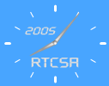 | 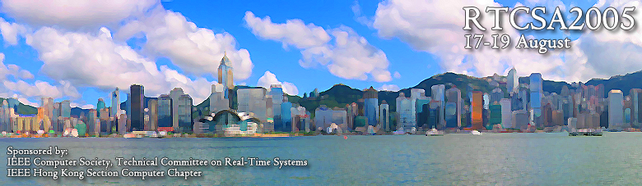
  Advisory Committee  Insup Lee, U. Penn., USA  Jane Liu, Academia Sinica, Taiwan  Al Mok, UT Austin, USA  Seung-Kyu Park, Ajou U., Korea  Heonshik Shin, SNU, Korea  Kang G. Shin, U. Michigan, USA  Kenji Toda, AIST, Japan  Hideyuki Tokuda, Keio U., Japan  Steering Committee  Tei-wei Kuo, NTU, Taiwan  Jorgen Hansson. Linkoping, Sweden  Seongsoo Hong, SNU, Korea  Tatsuo Nakajima, Waseda U, Japan  Joseph K. Ng, HKBU, HK  Sang H. Son, U. Virginia, USA  Organizing Committee  General Co-Chairs  Joseph K. Ng, HKBU, HK  Lui Sha, UIUC, USA  Program Co-Chairs  Real-Time Computing Track  Victor C. S. Lee, CityU, HK  Ubiquitous Computing Track  Kazunori Takashio, Keio U, Japan  Embedded Computing Track  Minsoo Ryu, HanYang U, Korea  Industry Track  Lionel Ni, HKUST, HK  Finance  Henry Chan, PolyU, HK  Registration  C. H. Li, HKBU, HK  Publication  Kelvin Wong, HKBU, HK  Local Arrangement  Karl Leung, HKIVE, HK  Leah Poon, HKBU, HK  Publicity  Richard West, Boston U, USA  Heonshik Shin, SNU, Korea  Tatsuo Nakajima, Waseda U, Japan  Tei-Wei Kuo, NTU, Taiwan  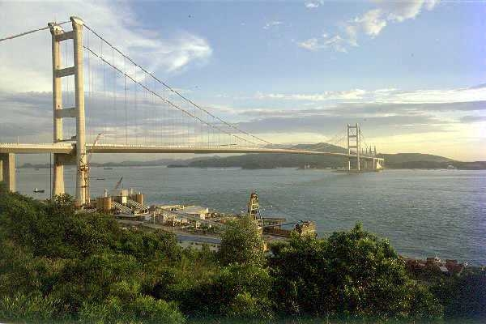 | Final Call for Papers  (Deadline extended to 8th April 2005)  RTCSA 2005 is going to be held in Hong Kong. Carry on with the tradition, the RTCSA conference series, will bring together researchers and developers from academia and industry for advancing the technology of embedded and real-time computing systems and applications.  RTCSA seeks both research and industry track papers that describe research or technical aspects in the area of embedded and real-time systems. Proceedings will be published by the IEEE Computer Society.  Scope of Conference  The 11th RTCSA will bring together researchers and developers from academia and industry for advancing the technology of embedded and real-time systems and ubiquitous computing applications. The conference has the following goals:  - to investigate advances in embedded and real-time systems and ubiquitous computing applications;  - to promote interaction among the areas of embedded computing, real-time computing and ubiquitous computing;  - to evaluate the maturity and directions of embedded and real-time system and ubiquitous computing technology.  RTCSA 2005 seeks papers that describe original research in the area of embedded and real-time systems and ubiquitous computing. This include, but is not limited to:  - embedded software / system on chip  - real-time / embedded operating systems  - ubiquitous/pervasive computing / information appliances  - hardware / software co-design  - QOS supports in OS / middleware  - design methodology and software architectures for embedded systems  - system support for mobile computing  - case studies / industrial experiences with building embedded applications  - government supported projects, open source projects  - sensor networks  Submissions  Both research and industry track papers are solicited. Research papers should be full papers describing original research; papers describing new ideas, promising approaches, experiences with practical and research systems are considered particularly appropriate. Industry track papers should describe interesting technical aspects of industrial applications, prototypes, experiences, and standards. Research papers must not exceed 16 double-spaced pages and industry track papers must not exceed 10 double-spaced pages. Papers should be submitted electronically through our web form in a pdf or postscript format. The material must be unpublished and not under submission elsewhere.  Special Issue for Selected Papers  Selected papers will be published in a Special Issue of Real-Time Systems Journal (Springer).  Important Dates  Extended Submission Deadline 8 April  Notification of Acceptance 10 May  Camera-ready Copy 1 June  Conference Dates 17-19 August | Program Committee  Ai-Chun Pang Taiwan  Albert M. K. Cheng USA  Alessio Bechini Italy  Aloysius K. Mok USA  Andrei Stefan Singapore  Anton Cervin Sweden  Bruno Sadeg France  C.K. Poon Hong Kong  Chang-Gun Lee USA  ChengKe Wu China  Chih-Wen Huseh Taiwan  Chi-Sheng (Daniel) Shih Taiwan  Claude Duvallet France  Daeyoung Kim Korea  David Taniar Australia  Dik L. Lee Hong Kong  Dong Xuan USA  Evaggelia Pitoura Greece  Farn Wang Taiwan  Giorgio Buttazzo Italy  Hans Hansson Sweden  Hidenori Nakazato Japan  Hiroaki Takada Japan  Hong-Va Leong Hong Kong  Iain Bate UK  Insup Lee USA  Jan Lindstrom Finland  Jiandong Li China  Jianhua Ma Japan  Jianliang Xu Hong Kong  Jiannong Cao HK  Jing Chen Taiwan  Jyh-Charn (Steve) Liu USA  KrithiRamamritham India  Kwei-Jay Lin USA  Kwok-Wa Lam Hong Kong  Laurence Yang Canada  Le Gruenwald USA  Leonard Barolli Japan  LihChyun Shu Taiwan  Lui Sha USA  Makoto Takizawa Japan  Mikael Nolin Sweden  MingLu Li China  Nimal Nissanke UK  Oleg Sokolsky USA  Petru Eles Sweden  Raj Rajkumar USA  Samarjit Chakraborty Singapore  Sang H. Son USA  Sang Lyul Min Korea  SangKeun Lee Korea  Sanjay Madria USA  Sanjoy K. Baruah USA  Tarek Abdelzaher USA  Timothy K. Shih Taiwan  Tom Henzinger USA  Vincent S. M. Tseng Taiwan  Wang Yi Sweden  Wang-Chien Lee USA  Wei Zhao USA  Weidong, Kou China  Wei-Kuan Shih Taiwan  Wolfgang A. Halang Germany  Xiang Liu China  Yann-Hang Lee USA  Yoshiaki Kakuda, Japan  Young-Kuk Kim Korea  ZhaoHui Wu China  Zoubir Mammeri France  Zied Choukair France
Organized by: Sponsored by:

http://www.comp.hkbu.edu.hk/~rtcsa2005

