China Heritage Tour
Duration: 6 Days / 5 Nights (December 23, 2006)
Itinerary: Hong Kong – Beijing – Xian – Hong Kong
Day 1: Hong Kong – Beijing
Meet and greet at the Hong Kong International Airport and take the flight to Beijing. Have a short city tour upon the arrival. Transfer to designated Hotel and enjoy your free-leisure time to explore the city by visiting the Night Market. Dinner at your own arrangement.
Day 2: Beijing (Breakfast, Lunch and Dinner included)  Today, take an excursion to the Great Wall, the longest man-made object in the world. The 6,350km Great Wall was first constructed in the 7th BC and extensions were done repeatedly in later dynasties. It is another UNESCO-endorsed cultural heritage site. Enjoy the dramatic vistas and marvel at the Wall as it climbs and descends steep ridges and narrow valleys. Visit the Summer Palace in the afternoon. It is the best-preserved imperial garden in China and was endorsed by UNESCO in 1998 as a world cultural heritage site. Following to Lao She Tea House to enjoy a taste of the art of brewing and drinking fragrant Chinese tea, accompanied by a performance by local fold artists is an additional. |  | 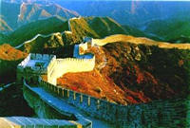
Day 3: Beijing (Breakfast, Lunch and Dinner included)  Enjoy a pedicab tour of Hutongs, the “old city” neighborhoods of narrow alley ways and courtyard gardens hidden behind Beijing’s modern façade. Then, guests will then be taken to the Forbidden City, the imperial palace for the Ming and Qing dynasties built between years 1406 – 1420. Visit Tiananmen Square, one of the world’s largest city squares which is large enough to hold 1 million people. Afterward, visit the Tiananmen Gate on the northern edge of the square used to be the front gate of the Ming and Qing Imperial Palace. Guests will be taken to the rostrum atop the gate, where national leaders review mass rallies or gala celebrations on important occasion, for a bird’s eye view of the Square. Enjoy a Peking Duck banquet to finish off the day. |  | 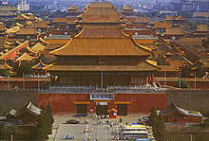
Day 4: Beijing – Xian (Breakfast and Lunch included)  Take the journey to Temple of Heaven, the largest temple complex and a UNESCO endorsed site. The Temple was built in 1420 and was the place where the Ming and Qing emperors prayed for good harvests for their kingdoms.  Transfer to Beijing Airport and take the flight to Xian, a city with a history of 3,000 years. If there is time available, a short city tour will be provided. Transfer to designated Hotel and enjoy your free-leisure time to explore the city by visiting the Night Market. Dinner at your own arrangement. |  | 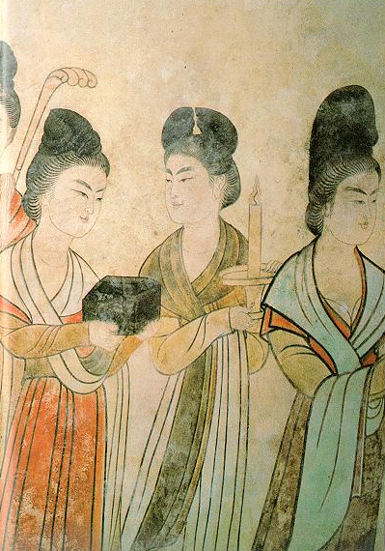
Day 5: Xian (Breakfast, Lunch and Dinner included)  In the morning, discover the unique, world-famous Terracotta Warriors and Horses Museum. Terracotta Warriors, is said to be Qin Shihuang’s Army 2000 years ago and it is built to protect the grave of the king. In the afternoon, visit the Big Wild Goose Pagoda, with the history of ten centuries, it is the best reserved Pagoda in Xian. |  | 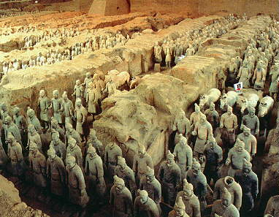
Day 6: Xian – Hong Kong (Breakfast and Lunch included)
In the morning, take the tour to the City Wall and then travel to the fascinating Great Mosque in Xian’s Muslim Quarter. Transfer to the Xian Airport and take the flight to Hong Kong.
USD1,334.00 per person (Share Twin) | Single Room Supplement: USD280.00
** Guarantee for departure with min. of 2 pax.
** Please see Tour Regulations for tour details.

Tour Regulations:

All the above tours are inclusive of:
- English speaking tour guide
- transfer by shuttle bus as mentioned in the itineraries
- Economy class airfare, if applicable
- Hotel accommodation (Half twin basis), Single Room Supplement charge will apply to Single traveler.
- Breakfast, lunch or dinner which as specified in the itinerary
- All admission fee to attractions as specified in the itinerary

All the above tours are exclusive of:
- China Visa Fee
- China, Taiwan and Hong Kong Airport taxes (To be confirmed upon the tour is guaranteed for departure)
- Hotel accommodation costs and the incidental expenses at hotel
- Excess luggage charges
- Tips for the driver and the tour guide

Remarks:
- All the above itineraries are subject to change due to unforeseeable situation out of CTS’s control, CTS will adjust the itinerary based on the actual situation.
- It is clients’ responsibility to bring the valid passport, identification cards and China Visa.
- The single room supplement will be added to the basic tour price for individual traveler(s).
- The information listed above for entry and exit China transportation and date is for reference only and is subject to change without prior notice.
- Since there is a possibility that the applicant may not be able to get the China VISA, we strongly suggest all participants should have their visa ready at least 1 week before the departure of the trip. If guest choose to do the group VISA and his/her application does not go through, there will be no refund of the trip.
- Hotels reserved for the above tours are 4 stars or similar hotels.
- We strongly suggest client purchase their tour insurance for their assurance.
- Cancellation Policy:
  - All cancellation must be made by the tour participants in writing or in person:
    - 14 working days and before prior to departure: 15% of the total tour fee.
    - 6-13 working days prior to departure: 60% of the total tour fee.
    - 6 working days or less prior to departure: no refund.

