COM 1008 – An Overview of Cloud Computing

Midterm review:

1. What is a computer?

A **computer** is an electronic device, operating under the control of instructions stored in its own memory

A process flow diagram shows three step of operations: Accepts data (input), Processing, Produces information (output).



Major components of a computer:

Internal hardware:

1. Processor: also called the **central processing unit** (**CPU**), interprets and carries out the basic instructions that operate a computer
2. Memory: (also called random access memory (RAM)) is the location that store instructions waiting to be executed by the processor (CPU), and the results of the processed data from the CPU.
3. Hard disk: (also called secondary memory/storage) is the location that programs or data will be kept permanently until deleted by the users.
4. Network Interface Card (NIC): is used to connect to network or Internet.

External hardware:

1. Monitor: is for the display.
2. Keyboard: is for input data into the computer.
3. Mouse: is used for Graphical User Interface.
4. Printer: is used for output hard copy.
5. Scanner: is for input pictures or documents into the computer.

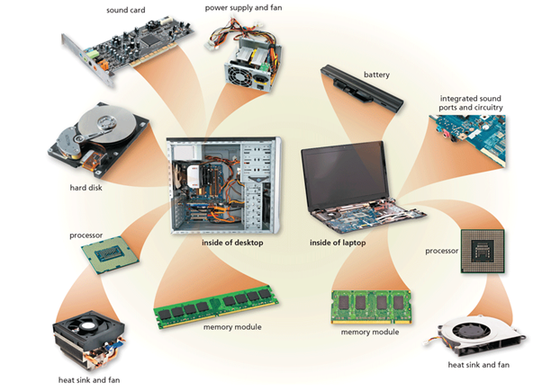

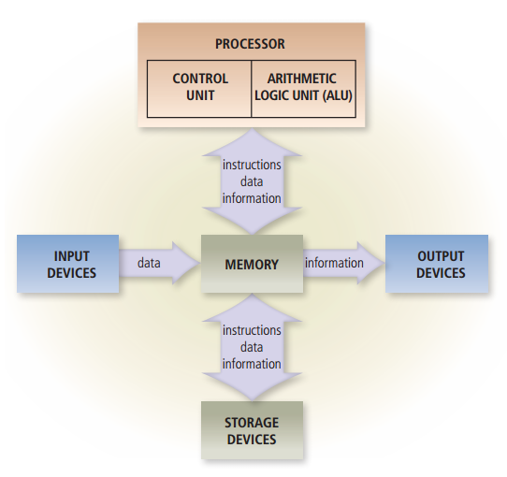

1. What is an Operating System (O/S)?

An operating system is a set of programs that coordinates all the activities among computer or mobile device hardware. Tools, or utilities, enable you to perform maintenance-type tasks usually related to managing devices, media, and programs used by computers and mobile devices. The operating system and other tools are collectively known as system software because they consist of the programs that control or maintain the operations of the computer and its devices.

Desktop operating systems include macOS, Windows, Linux, and Chrome OS. Mobile operating systems include Android, iOS, and Windows Phone

|  |
| --- |
| Apps/Users |
| O/S |
| Hardware |

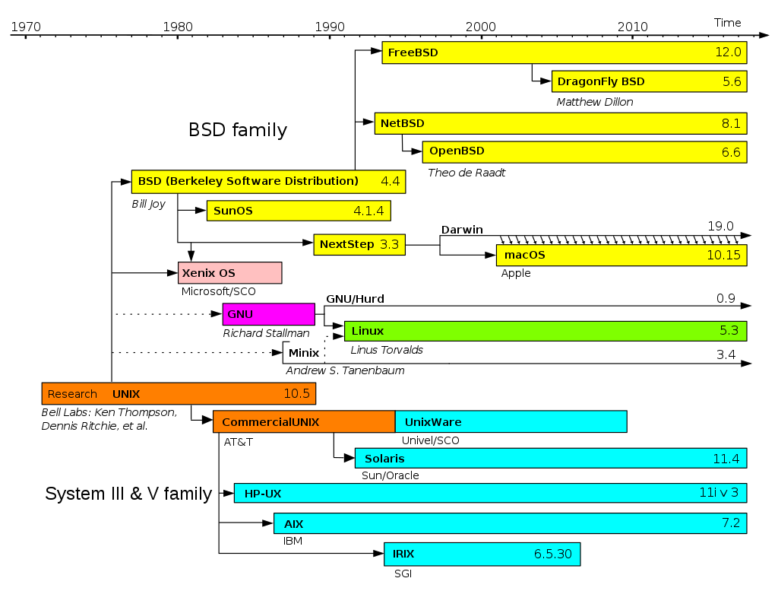

For Windows:

It is started from MS-DOS, Windows 1.0 was build on top of the MS-DOS, and so on including Windows 10 also build on MS-DOS (therefore, we can use MS-DOS commands in cmd.exe)

|  |
| --- |
| Windows |
| MS-DOS |

For macOS:

It was started from UNIX – BSD (one kind of Unix), NeXtStep was build on BSD (NeXtStep was founded by Steve Jobs), then come to Apple, created macOS build on top of Darwin OS. (See diagram from above)

|  |
| --- |
| macOS |
| Darwin |

For Linux:

It was started from UNIX, GNU, then Linux. (See diagram from above)

1. What is Cloud Computing?

**Cloud computing**:is set of resources and services offered through the *Internet*. [IEEE (*Institute of Electrical and Electronics Engineer*)]

Resources = compute power, database, storage, applications, servers, networking, analytics and other IT resources.

1. What are cloud computing characteristics?

* ***On-Demand self-service*** – any new services and changes (storage, memory, etc.) can be enabled without human interaction
* ***Broad Network access*** – services are accessible from standard network connection through thick and thin devices
* ***Resource pooling*** – resources are pooled and shared among all users – nothing is dedicated (The computing capabilities are pooled to serve multiple consumers using a multi-tenant model, with different physical and virtual resources dynamically assigned and reassigned according to consumer demand)
* ***Rapid elasticity*** – resources can be quickly scaled up, down, in or out based on demand (can be purchased in any quantity at any time.)
* ***Measured Service*** – resource usage is measured and shown to the user regularly including charge backs where applicable

1. What are benefits of cloud computing?

**Cost**: Cloud computing eliminates the capital expense of buying hardware and software and setting up and running on-site datacenters—the racks of servers, the round-the-clock electricity for power and cooling, the IT experts for managing the infrastructure. It adds up fast.

**Speed**: Most cloud computing services are provided self service and on demand, so even vast amounts of computing resources can be provisioned in minutes, typically with just a few mouse clicks, giving businesses a lot of flexibility and taking the pressure off capacity planning.

**Global Scale**: The benefits of cloud computing services include the ability to scale elastically. In cloud speak, that means delivering the right amount of IT resources—for example, more or less computing power, storage, bandwidth—right when its needed, and from the right geographic location.

**Productivity**: On-site datacenters typically require a lot of “racking and stacking”—hardware set up, software patching, and other time-consuming IT management chores. Cloud computing removes the need for many of these tasks, so IT teams can spend time on achieving more important business goals.

**Performance**: The biggest cloud computing services run on a worldwide network of secure datacenters, which are regularly upgraded to the latest generation of fast and efficient computing hardware. This offers several benefits over a single corporate datacenter, including reduced network latency for applications and greater economies of scale.

**Reliability**: Cloud computing makes data backup, disaster recovery, and business continuity easier and less expensive, because data can be mirrored at multiple redundant sites on the cloud provider’s network.

1. What is pay-as-you-go/consumption-based model?

End users only pay for the resources that they use. Whatever they use is what they pay for.

1. What is “Economies of Scale”?

The concept of ***economies of scale***is the ability to do things more cheaply and more efficiently when operating at a larger scale in comparison to operating at a smaller scale.

1. What is “Capital Expenditure (CapEx)”?

This is the spending of money on physical infrastructure up front, and then deducting that expense from your tax bill over time

1. What is “Operational Expenditure (OpEx)”?

This is spending money on services or products now and being billed for them now.

1. What is “Virtualization”?

**Virtualization** is the enabling technology and creates virtual machines that allows a single machine to act as if it were many machines

1. What is a “Virtual machine”?

known as a guest, is a software computer (emulation of a computer system) that provide the same functionality as physical computer

1. What is a “Physical machine”?

known as a host, is a computer that converts into multiple virtual machines.

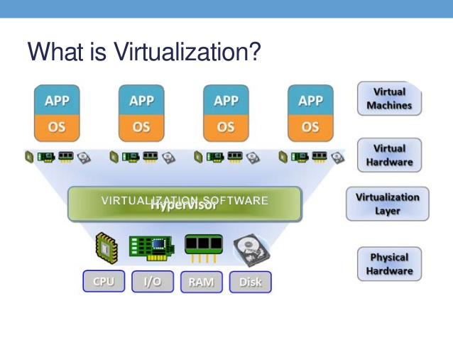

1. What is “Hypervisor/Virtual Machine Monitor (VMM)”?

It provides support for running multiple operating systems concurrently in virtual servers created within a physical server.

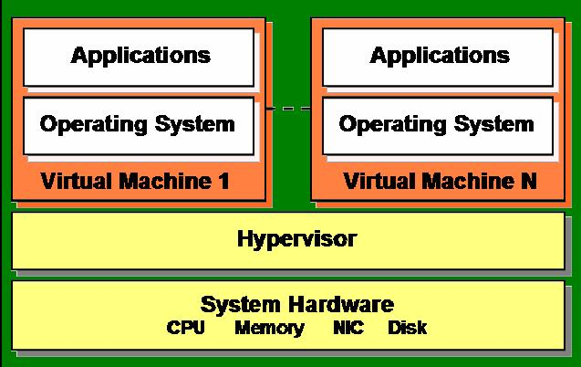

1. How many types of server virtualization?

* **Hardware-assisted Virtualization**: the hardware provides architectural support that facilitates building a virtual machine monitor and allows guest OSes to be run in isolation. (No hypervisor). Special CPU form Intel and AMD.
* **O/S-Level Virtualization**: (Homogeneous environment) a physical server is virtualized at the operating system level, enabling multiple isolated and secure virtualized servers to run on a single physical server. Host O/S = guest O/S. (No hypervisor).

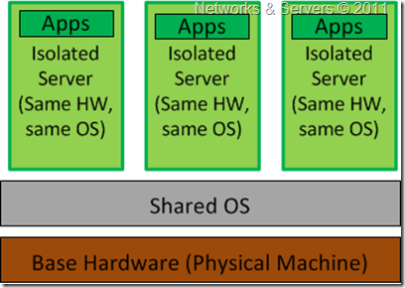

* **Software-Level Virtualization**: The hypervisor monitors the physical server's resources and keeps each virtual server independent. (Uses a hypervisor)

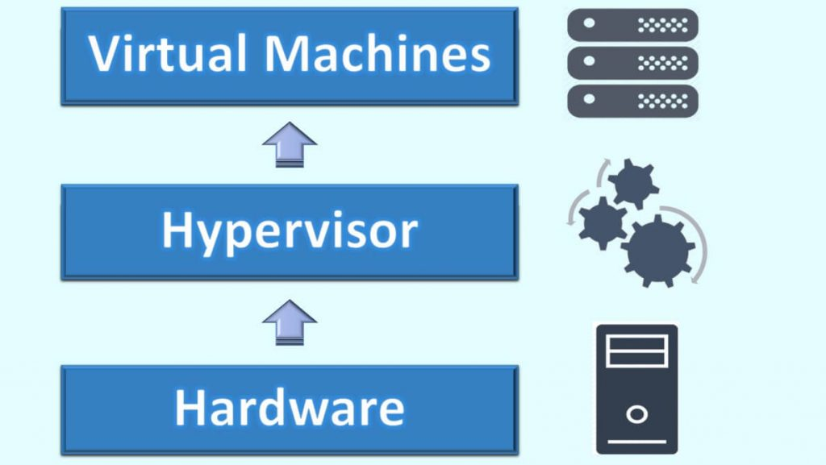

1. What is the “Windows Subsystem for Linux (WSL)”?

The Windows Subsystem for Linux (WSL) is a new Windows 10 feature that enables you to run native Linux command-line tools directly on Windows.

1. What is “Unix/Linux shell”?

the shell is a program that takes commands from the keyboard and gives them to the operating system to perform. In the old days, it was the only user interface available on a Unix-like system such as Linux. Nowadays, we have *graphical user interfaces (GUIs)* in addition to *command line interfaces (CLIs)* such as the shell.

|  |
| --- |
| Applications/Users |
| Shell [Bourne (sh), Korn (ksh), C shell (csh), Bourne-Again Shell (bash)] |
| Operating System (O/S) |
| Hardware |

1. How to set up WSL?

Please refer to your notes.

1. What is “VMware”?

**VMware** is a hypervisor installed on the physical server to allow for multiple virtual machines (VMs) to run on the same physical server.

1. How to set up virtual machine on Windows 10?

Please refer to your notes.

1. What is “Oracle VM VirtualBox”?

It is a cross-platform virtualization application (hypervisor).

1. How to set up virtual machine on Mac?

Please refer to your notes.

1. What are the five generation of computers?

* First generation of computers (1946-1954): vacuum tubes, large and expensive

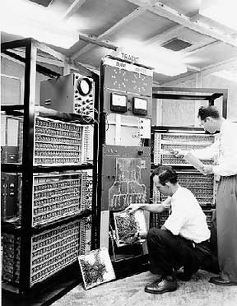

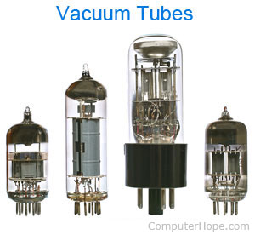

* Second generation of computers (1955-1964): transistors, large and expensive

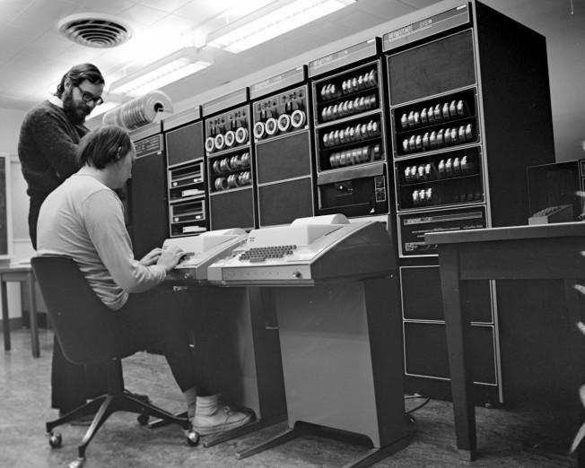

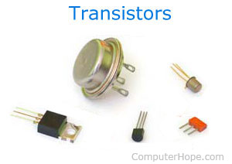

* Third generation of computers (1964-1977): integrated circuit, reduce in size

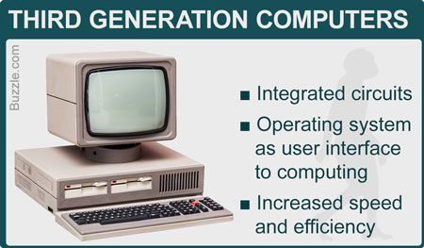

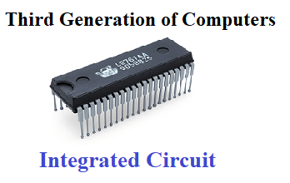

* Fourth generation of computers (1970): microprocessor, high speed, large storage

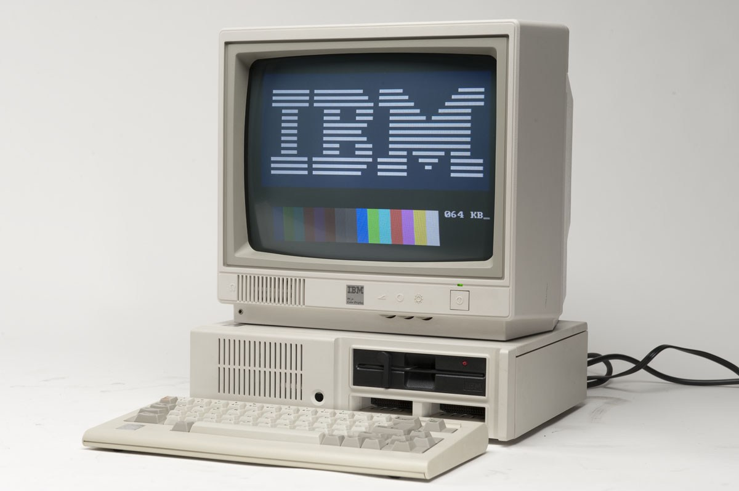

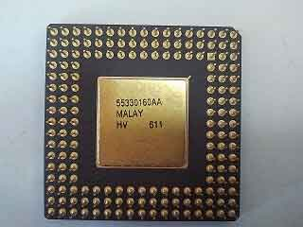

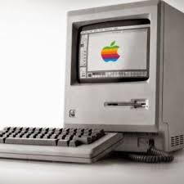

* Fifth generation of computers (1991 – continue): 64-bit microprocessor, memory chips, and flash memory, artificial intelligence.

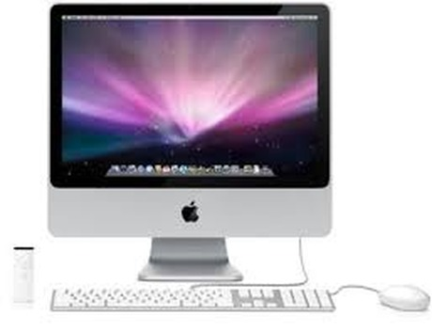

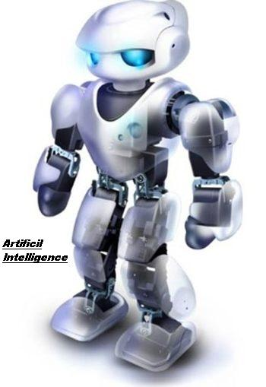

1. How many types of computers?

* Supercomputers are the largest, Fastest and Expensive Computer System in the world.

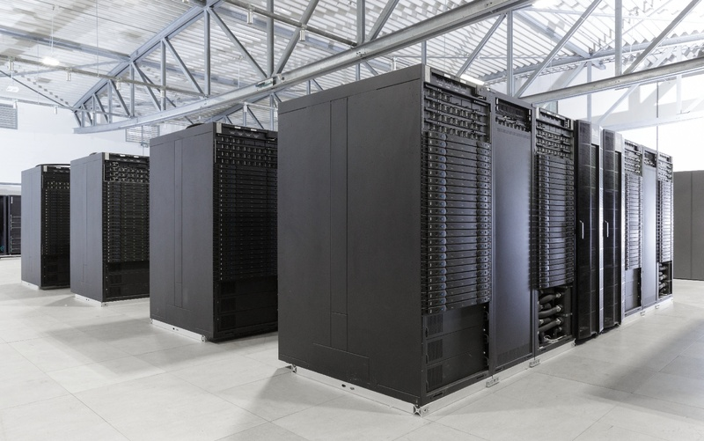

* Mainframe computers support a large numbers of terminals for used by a verity of users. (support a large numbers of users at the same time)

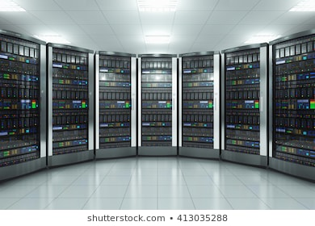

* Minicomputers are systems that support multiple users, also called Time Sharing System.

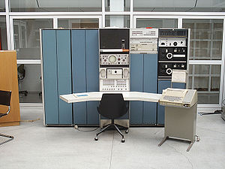

* Microcomputers are devices based on a single-chip microprocessor, also called personal computers.

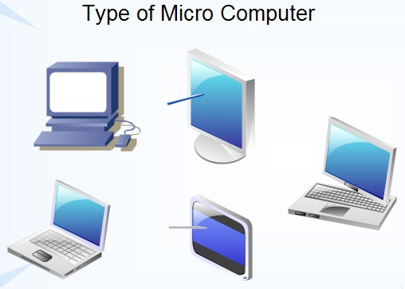

1. What is “thin client”?

Thin clients are computer terminals or software programs that rely on an external computer to perform work.

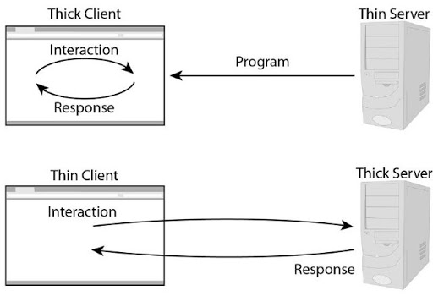

1. What is “Data Center”?

Data center is a physical facility that organizations use to house their critical applications and data.

1. How many types of data centers?

**Enterprise data centers**: These are built, owned, and operated by companies and are optimized for their end users. Most often they are housed on the corporate campus.

**Managed services data centers**: These data centers are managed by a third party (or a managed services provider) on behalf of a company. The company leases the equipment and infrastructure instead of buying it.

**Co-location data centers**: In co-location ("colo") data centers, a company rents space within a data center owned by others and located off company premises. The co-location data center hosts the infrastructure--building, cooling, bandwidth, physical security, etc. while the company provides and manages the components, including servers, storage, and firewalls.

**Cloud data centers**: In this off-premises form of data center, data and applications are hosted by a cloud services provider such as Amazon Web Services (AWS), Microsoft (Azure), or IBM Cloud.