Virtualization Outlines:

1. Operating System (O/S): is software that interface between hardware and applications/users.

Inside a computer:

|  |
| --- |
| Applications/Users |
| Operating System (O/S) |
| Hardware |

Hardware = CPU (Central Processing Unit), Memory, Hard disk (storage), Network Interface Card (NIC).

1. Virtualization: is a process that creates virtual machines allowing a single machine to act as if it were many machines. (the single machine is called a host machine or physical machine)
2. Virtual machines: is a guest machine or software computer (emulation of a computer system) that provide the same functionality as physical machine. (one physical machine with many virtual machines)
3. Platform/server virtualization: We only focus on this virtualization because it is related to cloud computing. (Platform = Operating System O/S)
4. Hypervisor/Virtual Machine Monitor (VMM):
   1. It provides support for running multiple operating systems concurrently in virtual server created within a physical server.
   2. It is a software responsible for hosting and managing all virtual machines (It is between virtual machines and host’s hardware)
   3. It is running directly on the host hardware. (it is installed and run directly on the host machine, and communicated with host hardware)

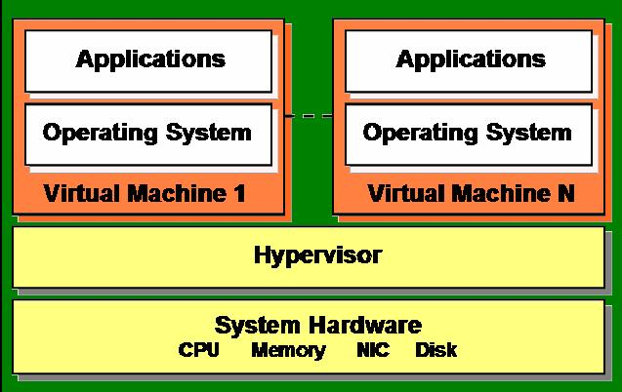

1. Different types of virtualization:

(A). No hypervisor/Virtual Machine Monitor (VMM):

1. Hardware-assisted virtualization. (Special CPU from Intel, AMD)

2. O/S-Level virtualization. Host O/S = guest O/S

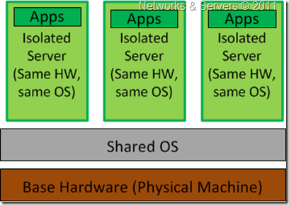

(B). Use hypervisor/Virtual Machine Monitor (VMM):

1. Type 1 or Type 2 hypervisor.

