Computer History Outlines:

1. History of Computers
2. **First generation of computers**: vacuum tubes, large, expensive

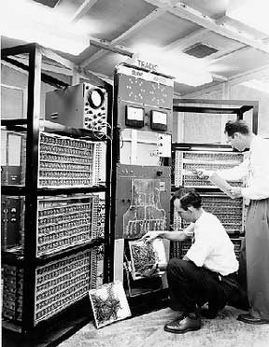

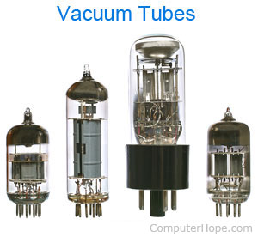

1. **Second generation of computers**: transistors, speed faster

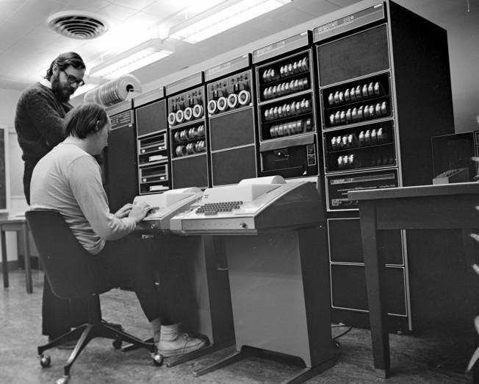

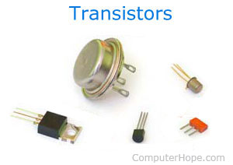

1. **Third generation of computers**: Integrated Circuit (IC), reduced in size

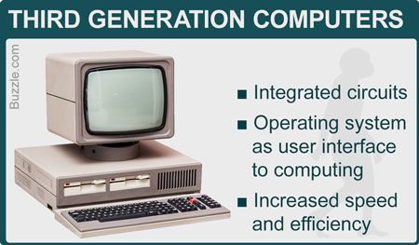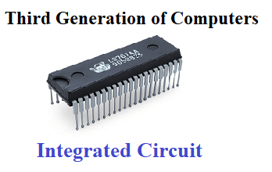

1. **Fourth generation of computers**: microprocessor, high speed of processing, large storage capacity

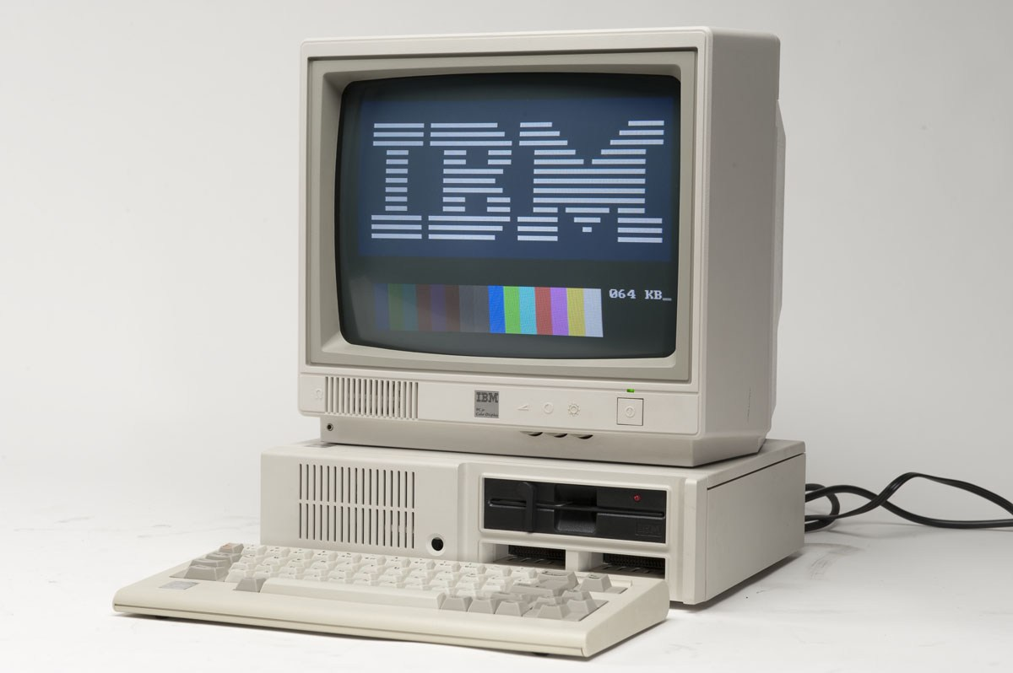

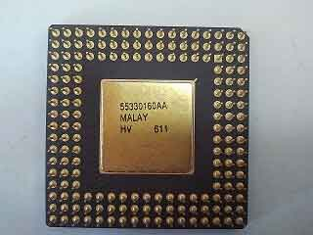

1. **Fifth generation of computers**: 64 bit microprocessor, memory chips and flash memory, artificial intelligence

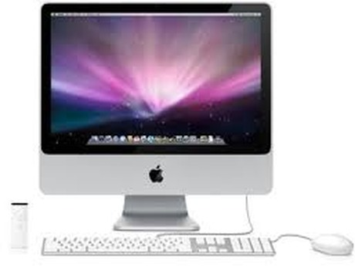

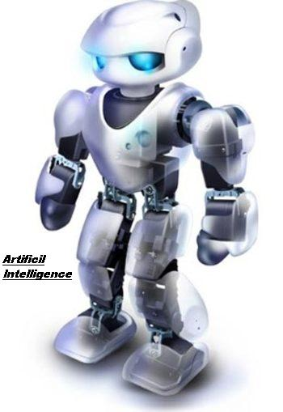

1. Classification of Computers
2. **Supercomputer** has internally large storage capacity and computing speed.

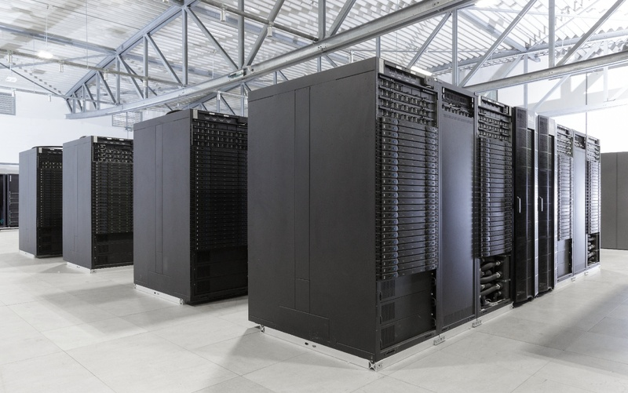

1. **Mainframe**: computer with a large storage capacity and very fast speed of processing compare to *Micro* or *Minicomputer*.

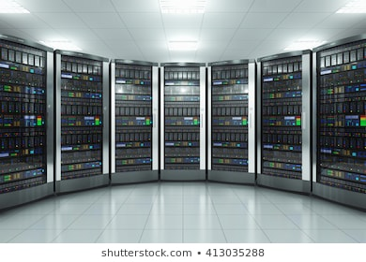

1. A **Minicomputer** (midrange computer) is a medium size i.e. more costly and powerful then a Microcomputer.

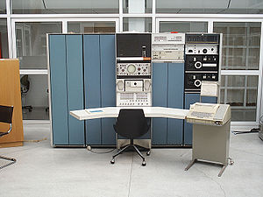

1. A **Microcomputer**is smaller to any other large systems.

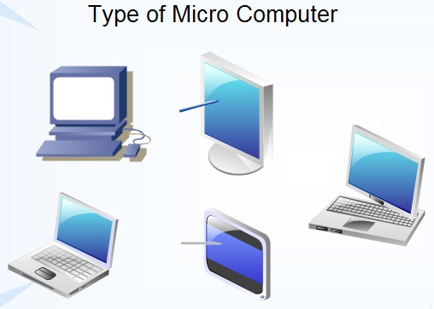

1. What is Thin Client?

[**Thin clients**](https://www.brighthub.com/environment/green-computing/articles/66417.aspx)are computer terminals or software programs that rely on an external computer to perform work.

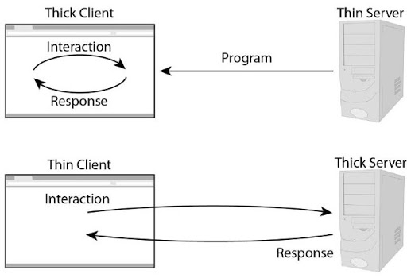

1. History of Thin Client

Oracle described Thin Client since 1993, but it actually started before 1990 known as “dumb terminals” from mainframe.

Advanced in technologies and reduced in cost, computer became localized in 1980 with O/S and Software installed in the PC.

Now, thin client offers flexibility and cost savings.

1. What is Data Center?

A **data center** is a physical facility that organizations use to house their critical applications and data.

1. Types of Data Centers
2. **Enterprise data centers**: These are built, owned, and operated by companies and are optimized for their end users.
3. **Managed services data centers**: These data centers are managed by a third party on behalf of a company. The company leases the equipment and infrastructure instead of buying it.
4. **Co-location data centers**: a company rents space within a data center owned by others. The co-location data center hosts the infrastructure--building, cooling, bandwidth, physical security, etc. while the company provides and manages the components, including servers, storage, and firewalls.
5. **Cloud data centers**: data and applications are hosted by a cloud services provider such as Amazon Web Services (AWS), Microsoft (Azure), or IBM Cloud.