Cloud Model Outlines:

1. What are cloud services?

Cloud services are (1) infrastructure, (2) platforms, or (3) software that are hosted by third-party providers and made available to users through the internet.

1. It includes the following as-a-Service solutions:
   1. Infrastructure-as-a-Service (IaaS): provides users with compute, networking, and storage resources.



* 1. Platform-as-a-Service (PaaS): provides users with a platform on which applications can run, as well as all the IT infrastructure required for it to run.

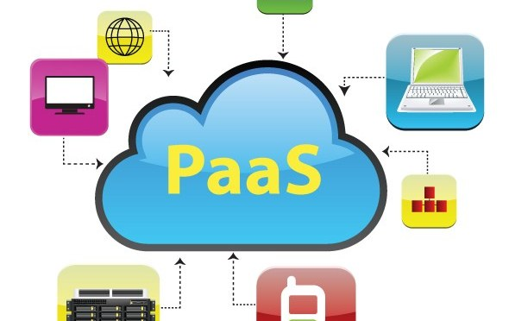

* 1. Software-as-a-Service (SaaS): provides users with a fully functional app, as well as platform on which it runs and the platform’s underlying infrastructure.

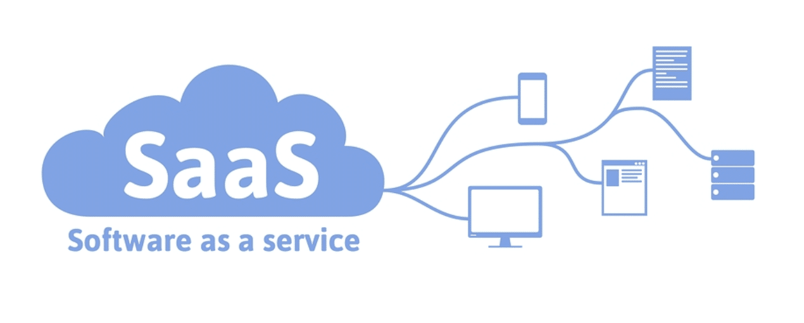

1. Cloud models:

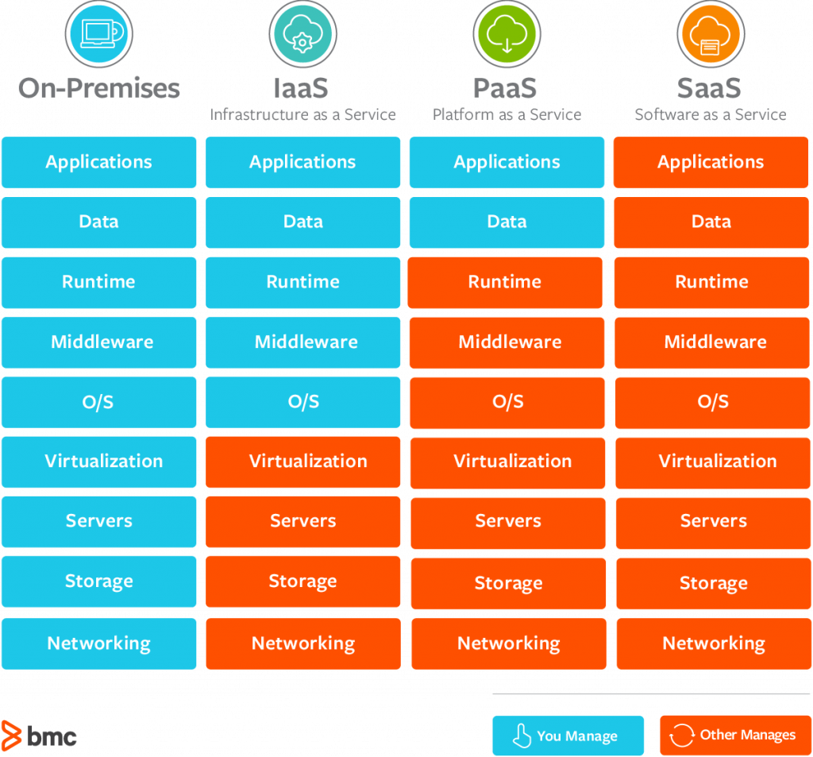

1. Cloud deployment models (Private, public, and hybrid clouds) (IaaS):

When deciding how to host data and apps on the cloud, companies often choose between sharing a server on the cloud with other organizations, configuring a dedicated server on the cloud, or using both options.

1. Private cloud: a company has its own servers in the cloud to host its apps and data.

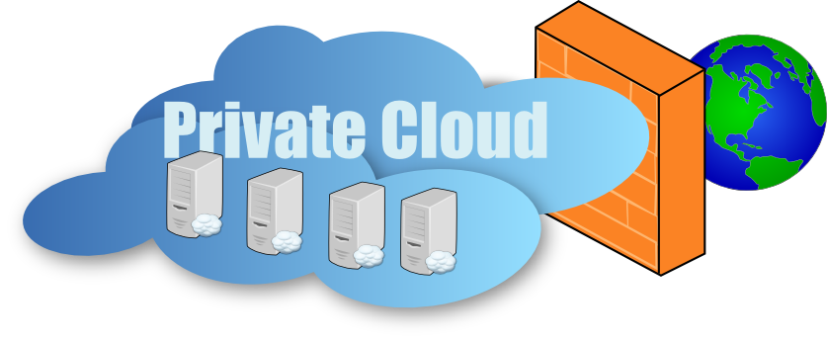

1. Public cloud: several companies store data or apps on the same physical server on the cloud.

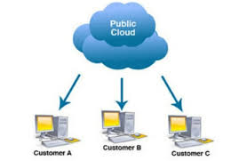

1. Hybrid cloud: organizations may host confidential data on a private cloud and rely on a public cloud for information that does not require such a high degree of security.

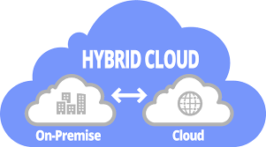

1. Example of cloud providers:
   1. Microsoft Azure

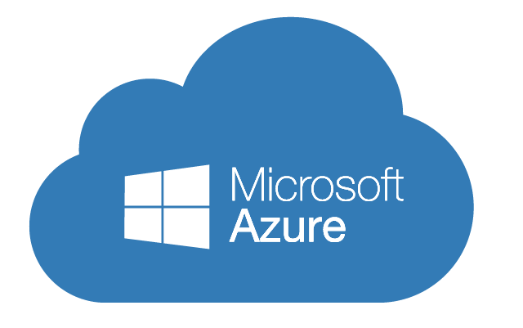

* 1. Amazon Web Services (AWS)



* 1. Google cloud:

