Chapter 5 – Business-to-Business Activities

1. Basic business functions

A **business** consists of four basic functions in order to be successful.

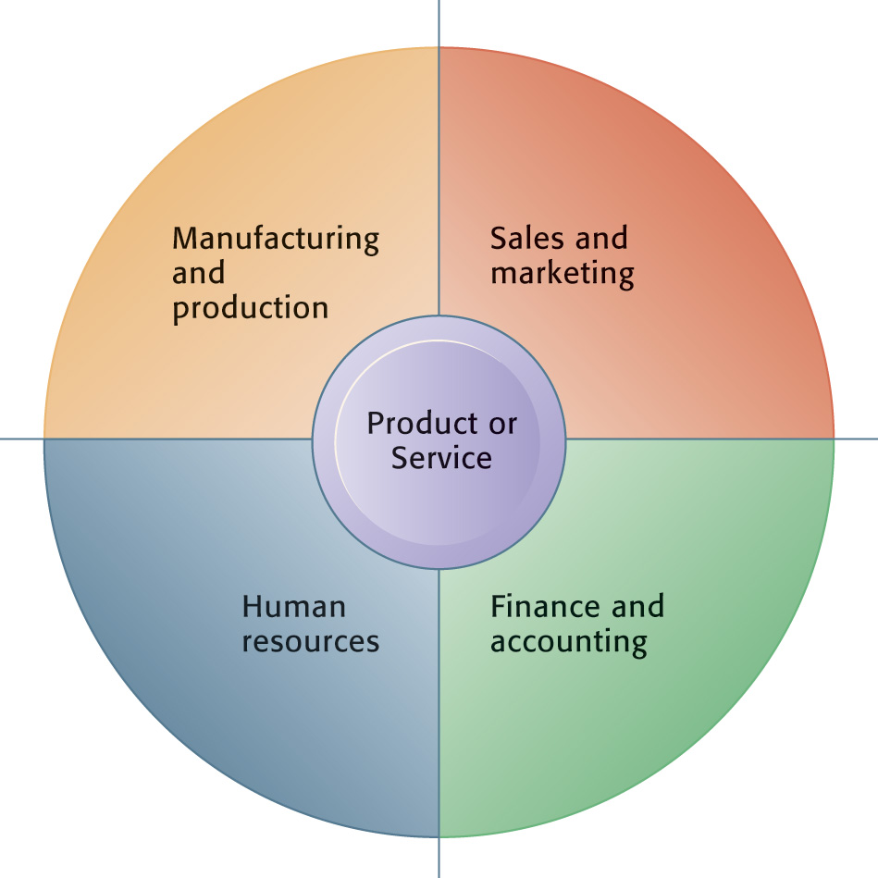

* In a successful business, the four basic functions will work seamlessly together to serve five entities:
  + Suppliers
  + Customers
  + Employees
  + Invoices/payments
  + Products and services

1. There are four major enterprise applications typically used to make an organization success.
   * **Supply Chain Management Systems (SCM)**
   * **Customer Relationship Management Systems (CRM)**
   * **Knowledge Management systems (KMS)**
   * **Enterprise Systems (AKA Enterprise Resource Planning (ERP))**
2. Outsourcing and Offshoring

The use of other organizations to perform specific activities is called **outsourcing**

When the outsourcing is done by organizations in other countries, it is often called **offshoring**.

1. Purchasing activities include identifying and evaluating vendors, selecting specific products, placing orders, and resolving any issues that arise after receiving the ordered goods or services.
2. Direct vs Indirect materials purchasing:

**Direct materials** are those materials that become part of the finished product in a manufacturing process.

There are two types of direct materials purchasing:

* + **Replenishment purchasing** (or **contract purchasing**): the company negotiates long-term contracts for most of the materials that it will need.
  + If demand is higher than the estimate need, it must buy additional materials during the year. This market is called a **spot market**.
  + Buying from this market is called **Spot purchasing**, the second type of direct materials purchasing.

**Indirect materials** are all other materials that the company purchases, including factory supplies (office supplies) such as sandpaper, hand tools, and replacement parts for manufacturing machinery.

1. **Logistics activities** include managing the inbound movements of materials and supplies and the outbound movements of finished goods and services.
2. Governments also perform businesslike activities; for example, they employ people, buy supplies from vendors, and distribute benefit payments of many kinds.

The use of Internet technologies by governments and government agencies to perform these functions is often called **e-government**.

1. **Electronic data interchange (EDI)** is a computer-to-computer transfer of business information between two businesses that uses a standard format of some kind.
2. How EDI works.
   1. **Steps to purchase using paper-based system**
   2. **Steps to purchase using EDI**
3. Trading partners can implement the EDI network and EDI translation processes in two ways: **direct connection or indirect connection.**
4. **direct connection EDI**, requires each business in the network to operate its own on-site EDI translator computer.

These EDI translator computers are then connected directly to each other using leased telecommunication lines.

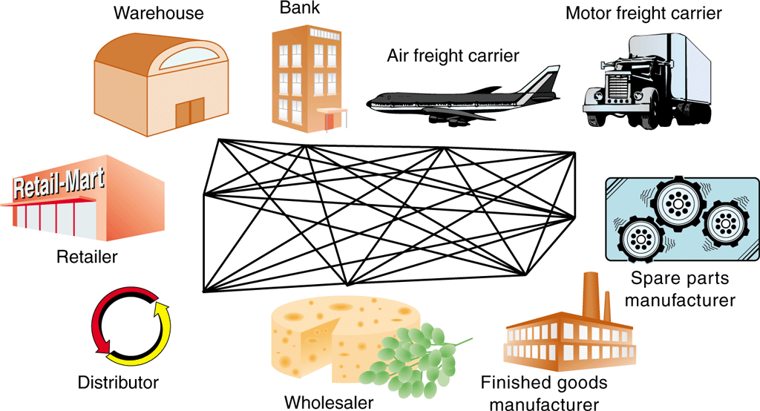

1. **indirect connection EDI** because the trading partners pass messages through the VAN instead of connecting their computers directly to each other.

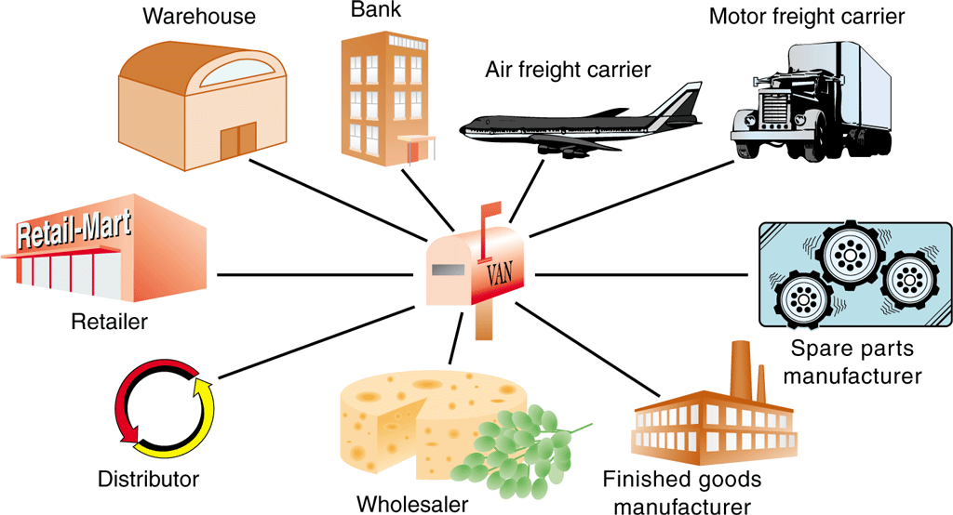

1. When EFTs involve two banks, they are executed using an **automated clearing house (ACH)** system, which is a service that banks use to manage their accounts with each other.
2. When companies integrate their supply management and logistics activities across multiple participants in a particular product’s supply chain, the job of managing that integration is called **supply chain management**.

The ultimate goal of supply chain management is to achieve a higher quality or lower-cost product at the end of the chain.

1. Materials-Tracking Technologies:
   1. Bar codes

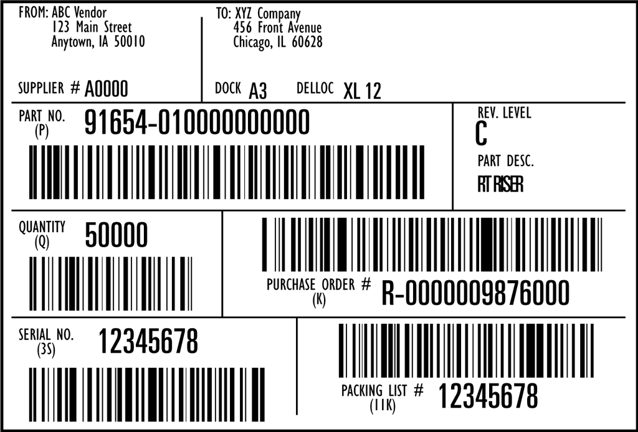

* 1. Active Radio Frequency Identification Devices (RFIDs)

RFIDs that have their own power supply are called **active RFIDs**

* 1. Passive Radio Frequency Identification Devices (RFIDs)

A **passive RFID**, which can be made cheaply and in very small sizes, does not need a power source.

